**Introduction to Machine Learning in Production**

**Week 1: Overview of ML lifecycle and Deployment**

* **Machine Learning project Life Cycle:**
* Data drift is one of the reasons that lead to varying performances in a production environment as compared to the development environment. Data drift means the changes in the data from the dev to the production environment

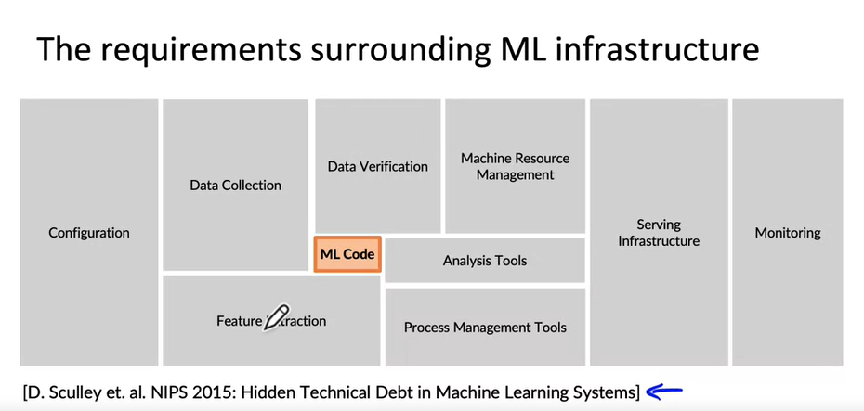

* when you deploy a system for the first time, you are maybe about halfway to the finish line, because it's often only after you turn on live traffic that you then learn the second half of the important lessons needed to get the system to perform well

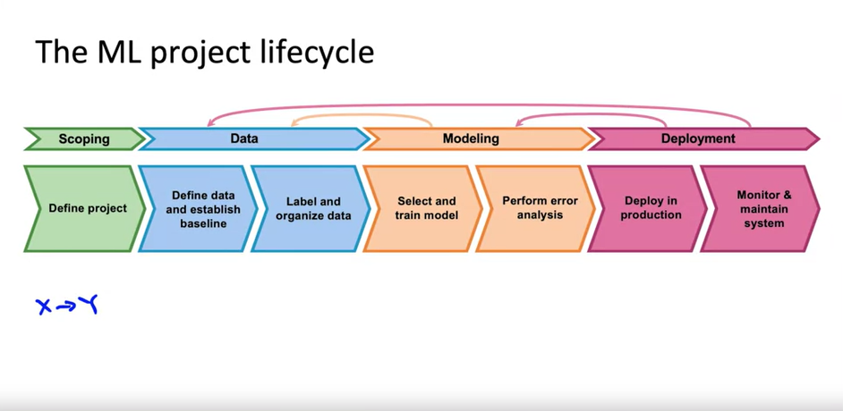

**CASE STUDY: Speech Recognition**

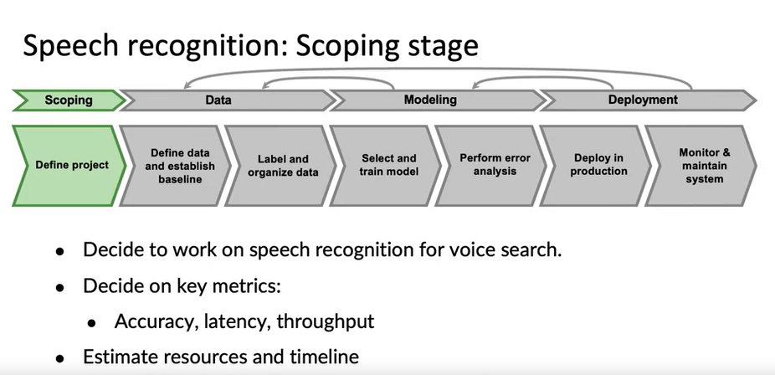

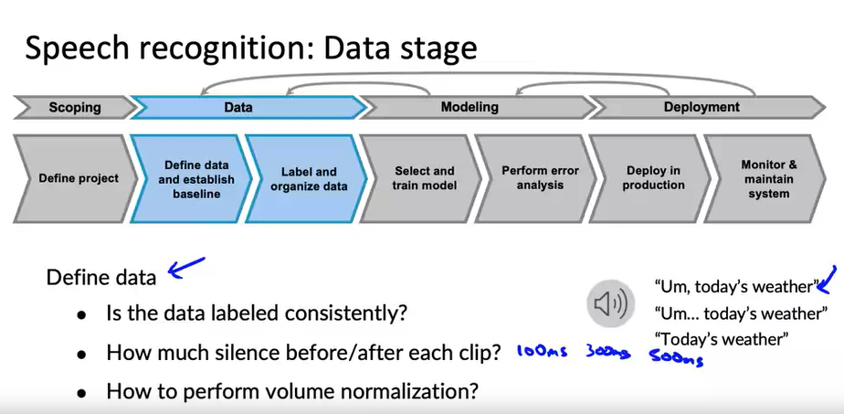

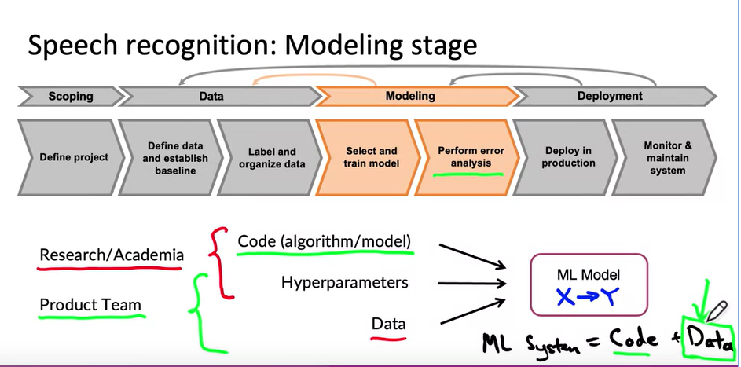

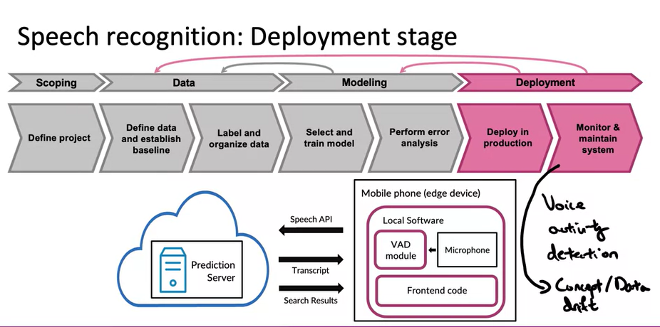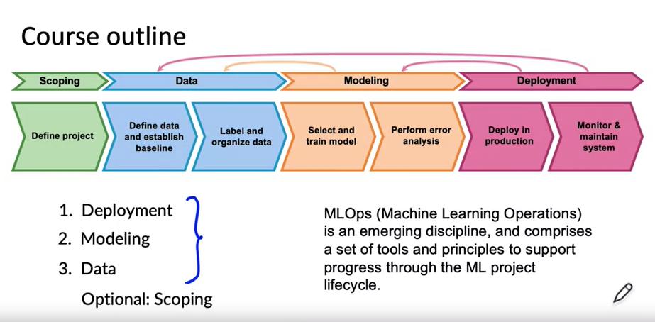

* **Deployment:**
* There are many challenges that happen after the deployment of ML models so we would discuss that.

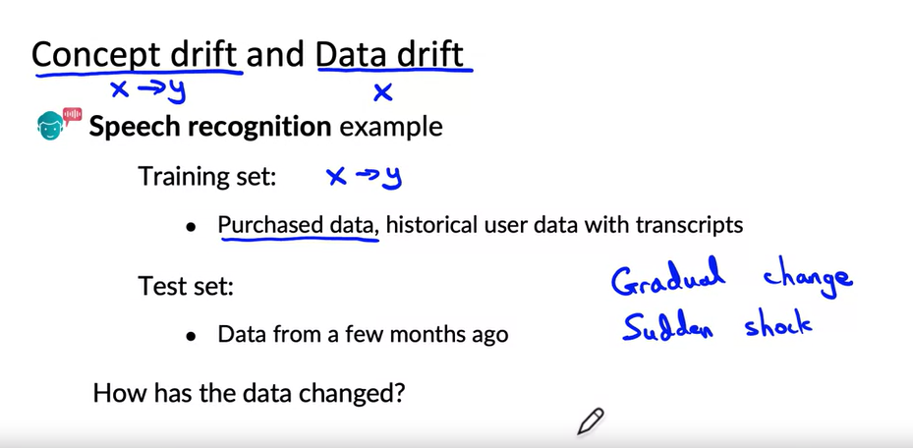

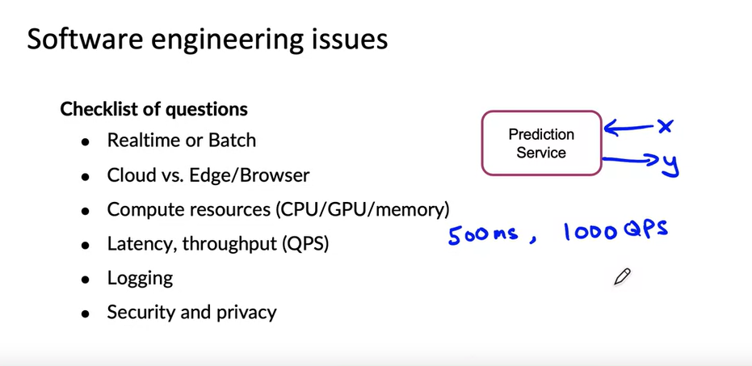

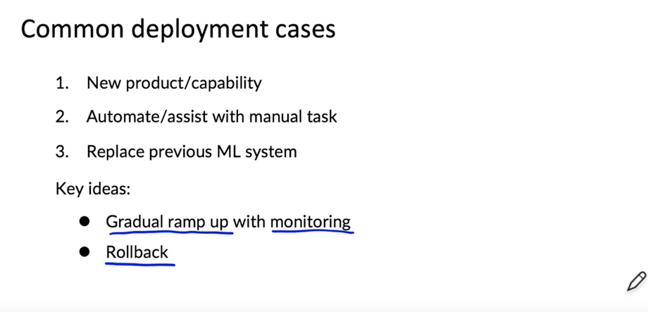

**Shadow Mode Deployment:**

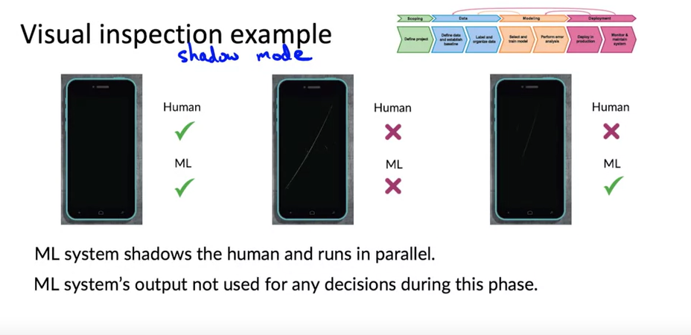

**Canary Deployment:**

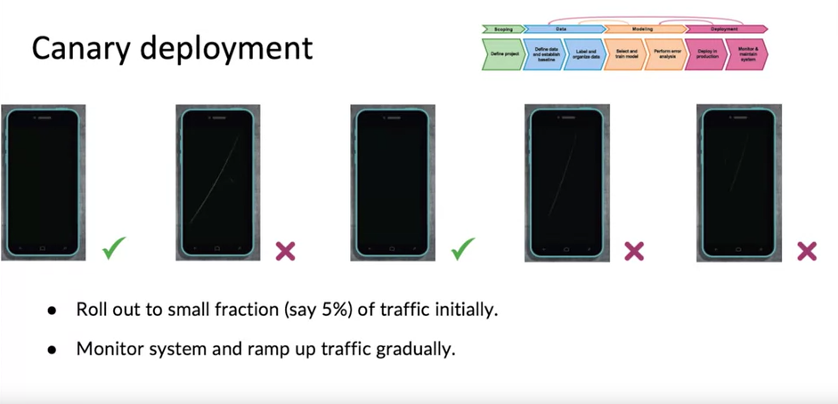

**Blue-Green Deployment:**

